Color Management Profiles

Editing

  - Ansly Azorie

Contents
Contents 3
Color Management profiles 4
Find “Color Management” application: 4
Click “All profiles”: 4
Click “Add” and find folder with all profiles, select them and add them: 5
Go to Advanced settings: 6
Windows default profile, following Intel CFCA profile 6
Windows default profile, a bit edited is: 7
Different beings universal profile is: 8
A more human-like primitive profile is: 9
My back at the time personal following color management idea: 10

Color Management profiles

Find “Color Management” application:
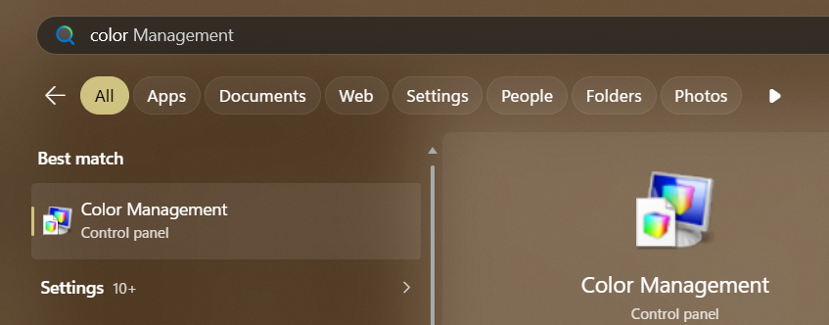

Click “All profiles”:


Click “Add” and find folder with all profiles, select them and add them:
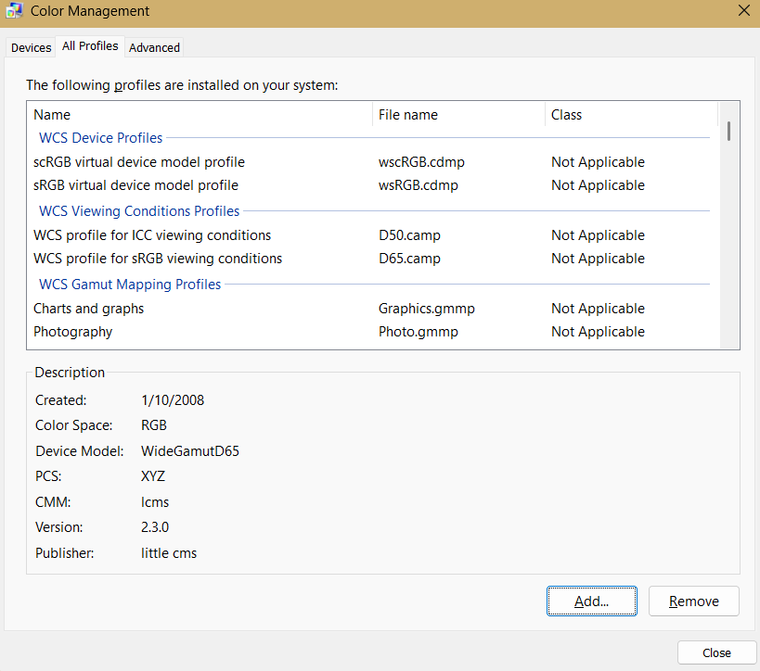

Go to Advanced settings:
My suggestion is “Chemical proof” profile....

Windows default profile, following Intel CFCA profile
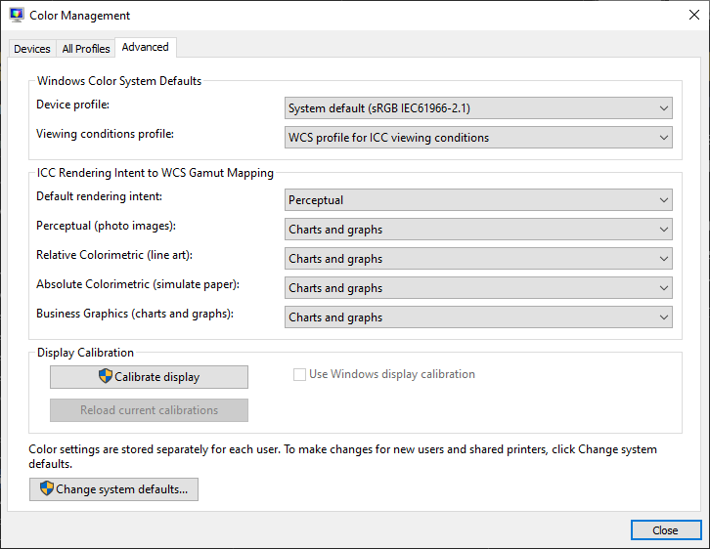

Windows default profile, a bit edited is:
- Profile works well for using it with “Quantum Wall”
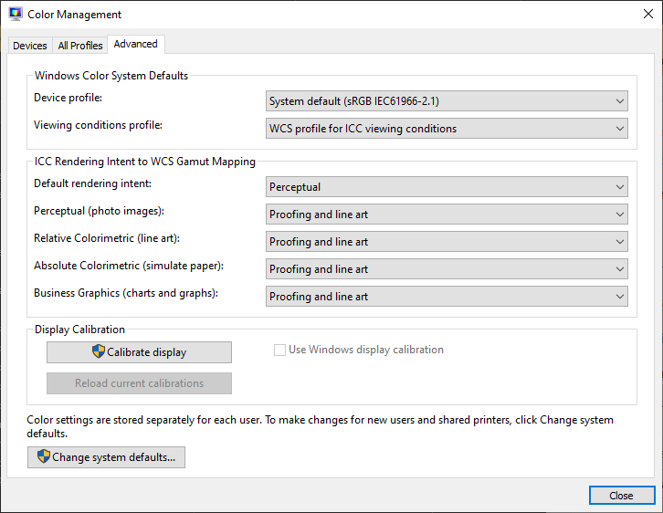

Different beings universal profile is:
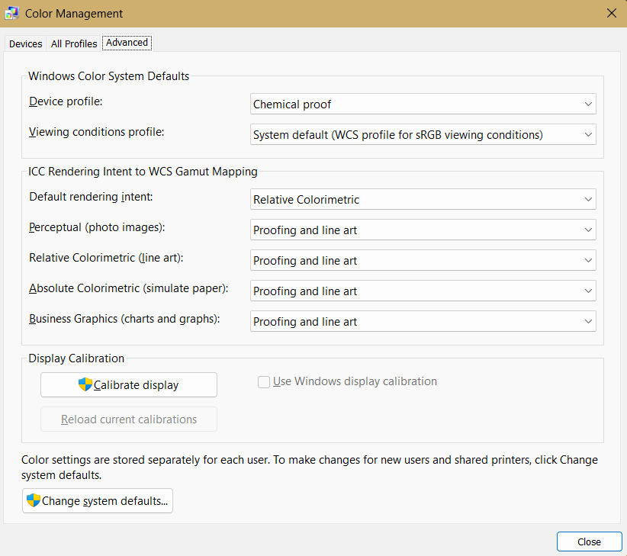

A more human-like primitive profile is:
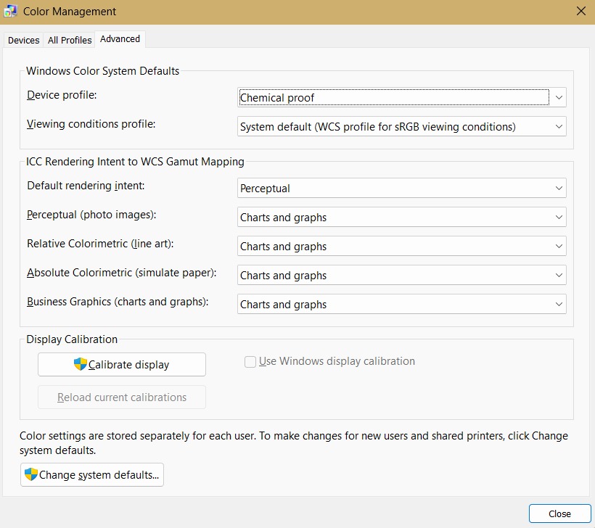

My back at the time personal following color management idea:
